Reading not floating from Meter CEWE using IEC-61850 Protocol

Contents

1. Treshold Value LNK_CAExplus signal source from CEWE Meter 2

2. CAExplus processing properties (FastTask: 10ms) 3

3. CAExplus processing Connection 4

4. Treshold Value LNK_CAExplus signal output to SCC 5

# Treshold Value LNK_CAExplus signal source from CEWE Meter

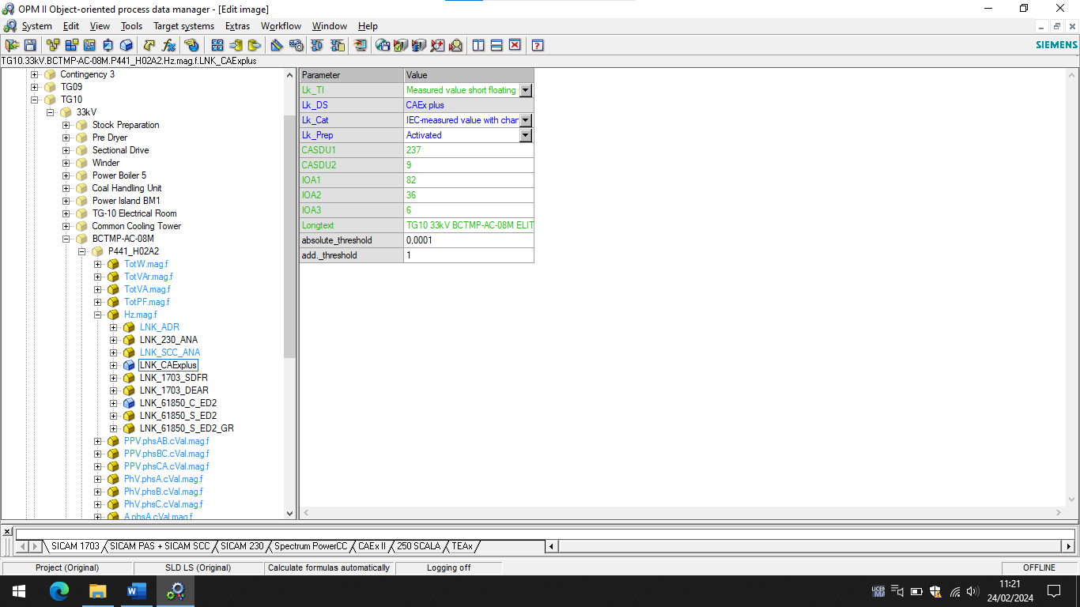

# CAExplus processing properties (FastTask: 10ms)

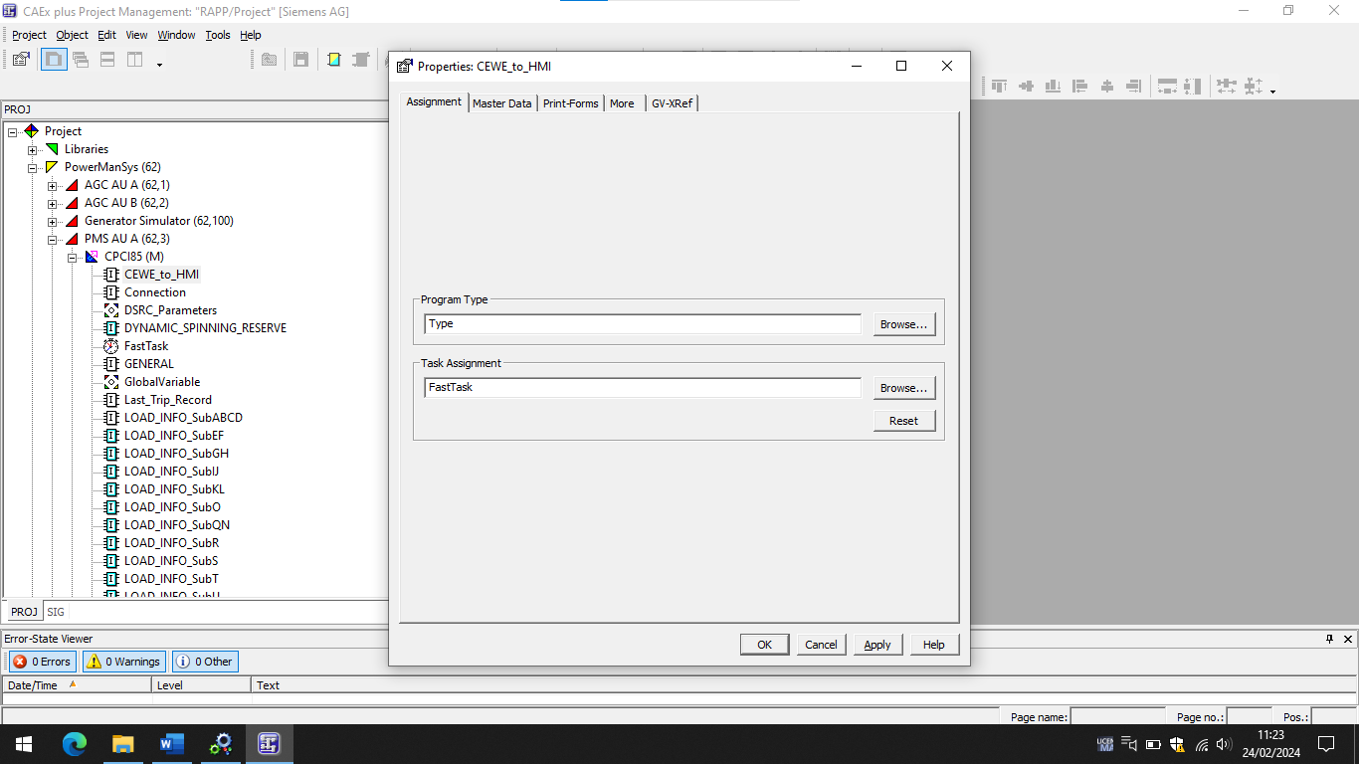

# CAExplus processing Connection

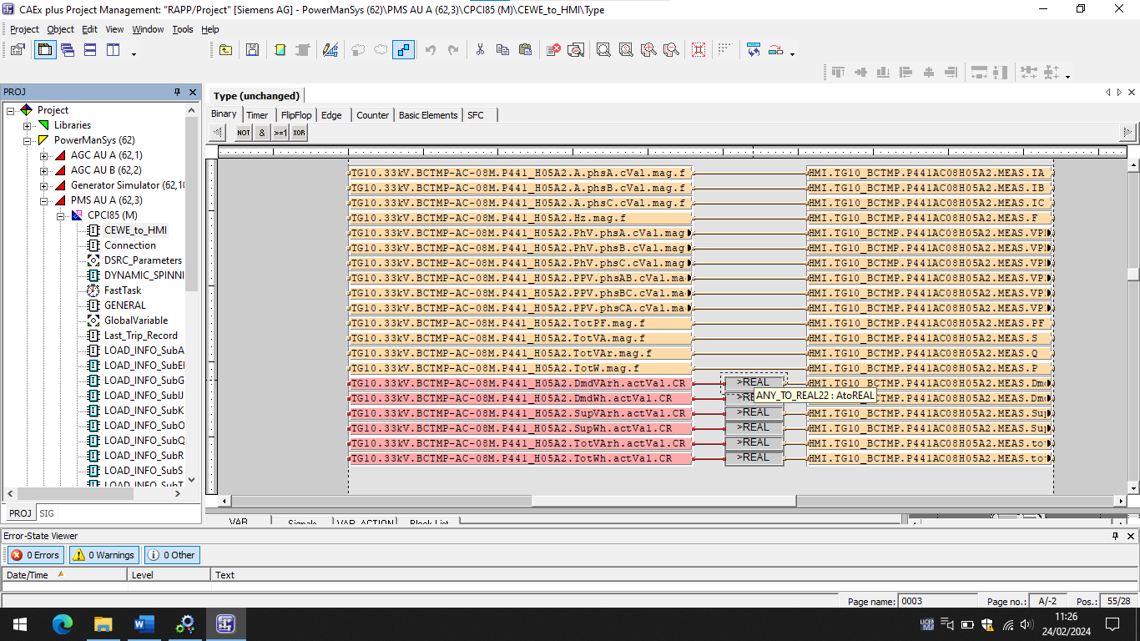

# Treshold Value LNK_CAExplus signal output to SCC

